Caribbean Institute for
Meteorology and Hydrology

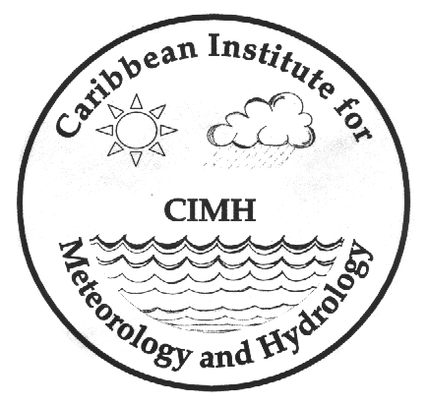

Training Courses 2008

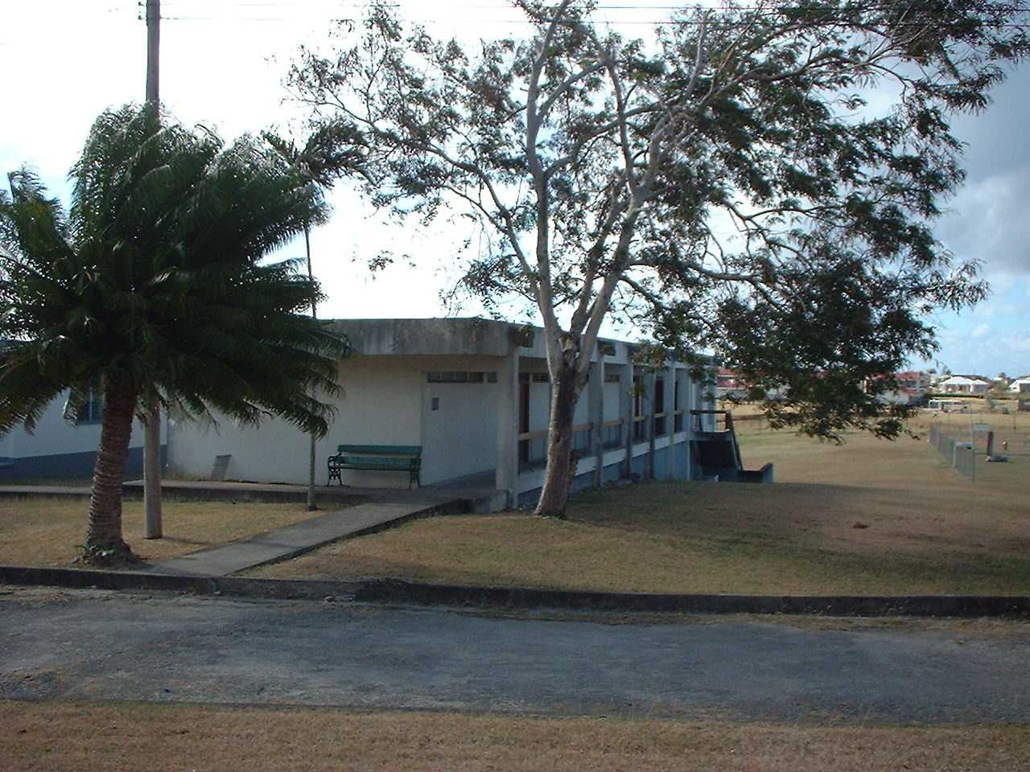

Caribbean Institute for
Meteorology and Hydrology

Training Courses 2014

The Caribbean Institute for

Meteorology and Hydrology

The Caribbean Institute for Meteorology and Hydrology is the regional Institution mandated to conduct training in Meteorology and Hydrology both of which are important to the development of the main economic sectors in the region.

The Institute was designated a Regional Meteorological Training Centre in 1978 (now referred to as a Regional Training Center) by the World Meteorological Organization (WMO) and was affiliated to the University of the West Indies (UWI) in 1973. The UWI offers meteorology as a major subject in its B.Sc. Programme and instruction is provided by the Institute’s staff. Students who have successfully completed the forecasters’ training programme are offered some exemptions when they register for the B.Sc. degree.

Meteorology programmes are offered at all four WMO classified levels (Entry Level Technicians, Mid Level Technicians, Senior Level Technicians and B.Sc.). Hydrology programmes are offered at General Technicians and Diploma levels. Other short courses in areas related to meteorology, climatology, agrometeorology and hydrology are offered from time to time.

Students are welcomed from any country worldwide, however, instruction is given in English only.

METEOROLOGY

ENTRY LEVEL TECHNICIANS COURSE No. 83/14

Duration: 14 March – 31 July 2014

This course for observers is intended to provide basic meteorological knowledge and practice in weather observing procedures and in the plotting of synoptic and aviation reports. On completion of the course participants are expected to:

(i) Be familiar with the procedures and rules governing the recording and coding of different weather elements.

(ii) Accurately code, decode and plot synoptic and aviation reports; plot data on surface synoptic charts, upper air charts and thermodynamic diagrams.

(iii) Extract hourly and daily data, and tabulate these data on climatological forms.

(iv) Determine when meteorological instruments are functioning properly.

Nominations close 24 January 2014

MID LEVEL TECHNICIANS COURSE No. 41/14

Duration: 14 March – 21 November 2014

This course is designed for senior Entry-Level Technicians specialising in one of the following:

- Applications of Meteorology;
- Instrument Maintenance, Repair and Calibration.

The Applications of Meteorology programme consists of elements of agrometeorology, climatology, hydrometeorology and aeronautical meteorology.

The course is intended for experienced observers who are expected to supervise and instruct Entry-level personnel and assist Senior-Level personnel with the processing of data and the preparation of meteorological and other information. Graduates are expected to:

(i) Have a thorough knowledge of the rules and regulations governing the observing, recording and use of meteorological and other data.

(ii) Quality control data and complete simple statistical and other analysis of the data.

(iii) Prepare summaries and reports of the analysed data

(iv) Assist with field and other experiments in the areas of specialisation.

(v) Inspect and set-up weather observation sites.

(vi) Maintain, repair and calibrate relevant meteorological instruments.

(vii) Assist with the briefing of pilots.

Nominations close 24 January 2014

SENIOR LEVEL TECHNICIANS COURSE No. 21/14

Duration: 10 January 2014 – 10 July 2015

This course is designed to train personnel as meteorological forecasters. All major areas of meteorology are taught, but emphasis is placed on tropical meteorology.

Graduates of this course are expected to:

- Know and understand the main physical and dynamical processes and phenomena associated with weather at all scales.

- Analyse and interpret synoptic weather charts and diagrams depicting current weather conditions.

(iii) Identify the physical and dynamical processes creating the weather conditions and be able to predict what conditions will evolve from the effects of these processes.

(iv) Interpret and use NWP products in the prediction of the weather.

(v) Interpret satellite imagery and use it in analysis and forecasting.

(vi) Prepare terminal and other forecasts for aviation and prepare documentation for use in flight planning and aircraft movement.

(vii) Know the weather conditions which are hazardous to the movement of aircraft and be able to predict these conditions.

Nominations closed
OPERATIONAL AERONAUTICAL FORECASTERS’ COURSE No. 5/14

Duration: 16 May – 18 July 2014

This course is specifically designed for applicants with a B. Sc in Meteorology preparing to become operational forecasters. It provides theoretical aeronautical and operational procedures with emphasis on the practical and operational applications of the theory to weather analysis and forecasting, particularly in the tropics. This course is designed to bring the applicants to a level that reflects the WMO first and second level competencies for Aeronautical Meteorological Forecasters (AMFs).
Graduates of this course are expected to:
- Analyze and interpret synoptic weather charts and diagrams depicting current weather conditions.
- Identify the physical and dynamical processes creating the weather conditions and be able to predict what conditions will evolve from the effects of these processes
- Interpret and use NWP products in the prediction of the weather
- Interpret satellite imagery and use these in analysis and forecasting
- Prepare terminal and other forecasts for aviation and prepare documentation for use in flight planning and aircraft movement
- Know the weather conditions which are hazardous to the movement of aircraft and be able to predict these conditions
- Familiar with the relevant ICAO and WMO standards, recommended practices and codes relating to aviation
Nominations close 7 March 2014

CIMH CONTINUING PROFESSIONAL DEVELOPMENT COURSE FOR AERONAUTICAL FORECASTERS No. 4/14

Duration: 26 September 2014 – 01 May 2015

This course is an online course set up for current operational forecasters. It provides additional training in the areas associated with aeronautical meteorology. This is to assist the forecasters to achieve and maintain the recommended approved Competence Standards for Aviation Meteorological Forecasting (WMO Publication No. 49, Technical Regulations, Volume I).
The minimum entry requirement for the course is successful completion of the BIP-M requirements as defined in the WMO Publication No. 258, ‘Guidelines to Education in Meteorology and Hydrology’. Hence, participants must be a graduate of the Senior Level Meteorological Technicians’ course and/or have a Bachelor’s Degree in Meteorology.

Nominations are open immediately and limited to two participants per forecast office.
Nominations close 21 September 2014

INSTRUMENT MAINTENANCE: Calibration & Laboratory Practices for Meteorologists INSTLP 1000 No.1/14
Duration: 5 – 9 June 2014

The course is designed to provide basic and practical knowledge for Meteorological Technicians in the area if calibration of sensors whilst providing exercise to the candidates in laboratory and field aimed at harnessing the skill set given theoretical information on offer.

Theoretical Component:

- Calibration Methods and Techniques for Digital Pressure Sensors.
- Calibration Methods and Techniques for Rain Gauges.
- Calibration Methods and Techniques for Relative Humidity and Temperature sensors.
- Calibration Methods and Techniques for Winds Sensors.
- Quality Management Mechanism for Data Collection and Archiving.
- Instrumentation and Laboratory Management Systems and Quality Management Systems.
- Quality Assurance Methods for Instrumentation and Data Collection.

Practical Component:

- Exercises in calibration of Rain Gauges, AT/RH Sensors, Digital Pressure Sensors and Wind Speed and Wind Direction.
On completion each candidate is expected to:

- Possess the requisite knowledge in checking, verification and calibration of sensors including but not limited to digital pressure sensors, rain recorders, rain gauges, relative humidity sensors and temperature sensors.
- Accurately record, collect, verity and archive data from the aforementioned sensors.
- Determine when sensors are recording inaccurate data.
- Maintain and repair sensors, loggers and general meteorological equipment.
- Create and mange quality management and quality control systems.

Nominations close 25 April 2014

HYDROLOGY

HYDROLOGICAL TECHNICIANS COURSE No. HT 25/14

Duration: 29 August 2014 – 24 April 2015

This course is designed for hydrological technicians in areas of ground water, surface water, water quality and the acquisition and analysis of data. Fieldwork is normally conducted outside of Barbados.

Technicians completing this course successfully would be able to do the following:

(i) Provide continuous knowledge transfer and training to junior technicians through on-the-job training.

(ii) Conduct primary screening of hydrological data, simple analyses

(iii) Assist with preliminary hydrological studies

(iv) Assist with hydrological monitoring programmes

(iii) Assist hydrologists in research.

Nominations close 11 July 2014

DIPLOMA IN HYDROLOGY COURSE No. DipH 16/14

Duration: 10 January 2014 –10 July 2015

This course is designed to train personnel for the hydrological services in ground water, surface water and other related techniques and applications. Fieldwork is normally conducted outside of Barbados.

Technicians completing the Diploma course successfully are expected to:-

- Supervise hydrological technicians.

(ii) Carry out complete screening, analysis and dissemination of hydrological data for both surface and subsurface waters.

(iii) With guidance from the hydrologist, conduct fieldwork in hydrometry, geophysics, ground water extraction, well development and maintenance.

(iv) Assist hydrologists in operations and research.

(v) Collaborate with agencies in practical aspects of surface and ground water utilization.

Nominations closed

SHORT COURSES

Regional Drought Monitoring Analysis

Duration: 5 – 9 May 2014

Definitions of drought for various sectors will be given. Rainfall and evaporation data in Barbados and Eastern Caribbean will be collated and analyzed using statistical techniques; extreme rainfall minima from various time periods will be examined and probabilities of non exceedence determined; soil moisture and soil moisture deficits.

Nominations close 25 April 2014

Introduction To Water Resources Planning Using An Integrated Water Resources Management (IWRM) Approach

Duration: 12– 16 May 2014

This course uses an integrated water resources management (IWRM) approach which identifies critical water stressed areas; seeks to balance human, industrial, agricultural and environmental needs; explains why it is necessary therefore to involve everyone in water use (government, academics, agricultural and business interest, community groups, NGO’s) to joining forces so that they can share data and solve problems at all levels.

Nominations close 25 April 2014

Effects of Climate Variability/Change on Water Resources in the Caribbean

Duration: 19 – 23 May 2014

The course aims to examine the impacts of climate variability/change on water resources in the Caribbean by considering both water quantity and quality issues. Impacts include but are not limited to (i) more intense extreme events, (ii) a reduction in annual rainfall, (iv) sea level rise and (v) increased energy demand.

Nominations close 25 April, 2014

Environmental Impacts Related to Hydrological Systems

Duration: 25 August – 5 September 2014

This course examines natural and man-made disasters and their effects on surface and groundwater, the migration of pollutants such as oil, pesticides, landfill leachate into aquifers and environmental monitoring.

Nominations close 11 August, 2014

Flood HAZARD Mapping (oNliNE)

Duration: 8 – 19 September 2014

Participants will learn how to prepare data for flood analysis and will be given an introduction to flood hazard modelling and mapping and its use in quantifying damage from floods.

Nomination close 11 August, 2014

UNIVERSITY OF THE WEST INDIES

B.Sc. Degree in Meteorology

This is a three-year programme offered by the University of the West Indies in association with the CIMH.

For more information please refer to the UWI Cave Hill Campus Faculty of Pure and Applied Sciences Handbook (http://www.cavehill.uwi.edu/fpas/Handbooks/UWI.FPAS.Handbook2007-8.pdf. Additional information and an application form can be obtained from:

The Assistant Registrar (Student Affairs)
University of the West Indies
Cave Hill
St. Michael
Barbados, W.I.

GENERAL INFORMATION

The minimum qualifications for all courses, with the exception of the B.Sc. programme, are 4 CXC Grade I – III (or GCE ‘O’ level equivalent) certificates including English Language, Mathematics and Physics. In addition, candidates for the Mid Level Technician Course and Senior Level Technicians Course programme should also possess an Entry Level Technicians certificate.

The maximum number of students on each class is 15.

Requests for further information and applications should be sent to:

The Principal
Caribbean Institute for Meteorology and Hydrology
P.O. Box 130
Bridgetown
Barbados. W.I
.

Telephone: (246)-425-1362/65
Fax: (246) 424-4733
E-mail: dfarrell@cimh.edu.bb
dfarrell615@caribsurf.com
Webpage: http://www.cimh.edu.bb

M.Sc. Degree in Natural Resource and environmental management

This is a fifteen month M.Sc. programme offered by the Center for Resource Management and Environmental Studies (CERMES) at the University of the West Indies, Cave Hill Campus. Specializations within the programme that are taught by CIMH staff include Applied Meteorology, Surface Water Hydrology and Groundwater. More information on the M.Sc. programme can be obtained at http://cermes.cavehill.uwi.edu/gradprogs.htm

Potential applicants should contact:

Ms. Neetha Selliah
Project Coordinator
CERMES
neetha.selliah@cavehill.uwi.edu

